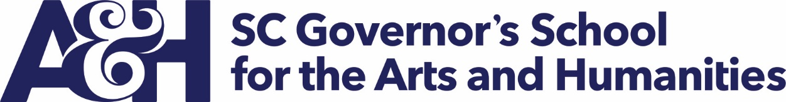

Carry Forward Information

SCGSAH carried forward from FY 2018 to FY 2019 $1,270,378 in the General Fund and $127,829 in EIA funds. Total appropriated state funds carry forward was $1,398,207.

SCGSAH other fund (Operating Revenue) cash balance at the end of FY 2018 was $1,255,976. These funds include summer program tuitions collected through June 2018 and expended in July and August 2018. The Operating Revenue fund carryforward also included $430,848 insurance payment for shingled roof replacement.

